**Lab 10  
DHCP / UDP**

**Objectives**:

Understand how to configure DHCP and how DHCP messages are encapsulated in **UDP segments.**

**Task 1 – Basic DHCP (50 points)**

1. Using Cisco Packet Tracer, configure this network:

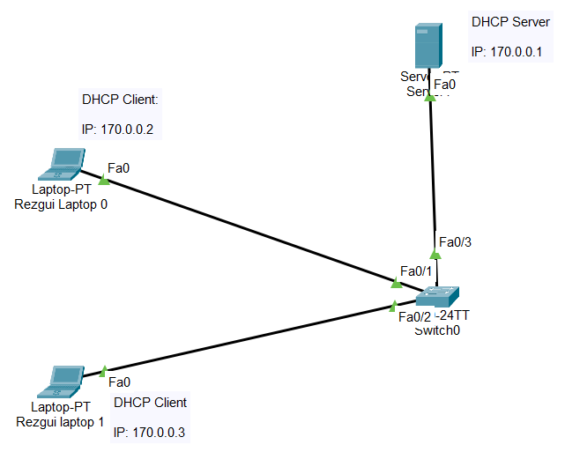

2. Show that Laptop 0 did acquire a valid IP address from the DHCP server (replace my screen capture with yours)

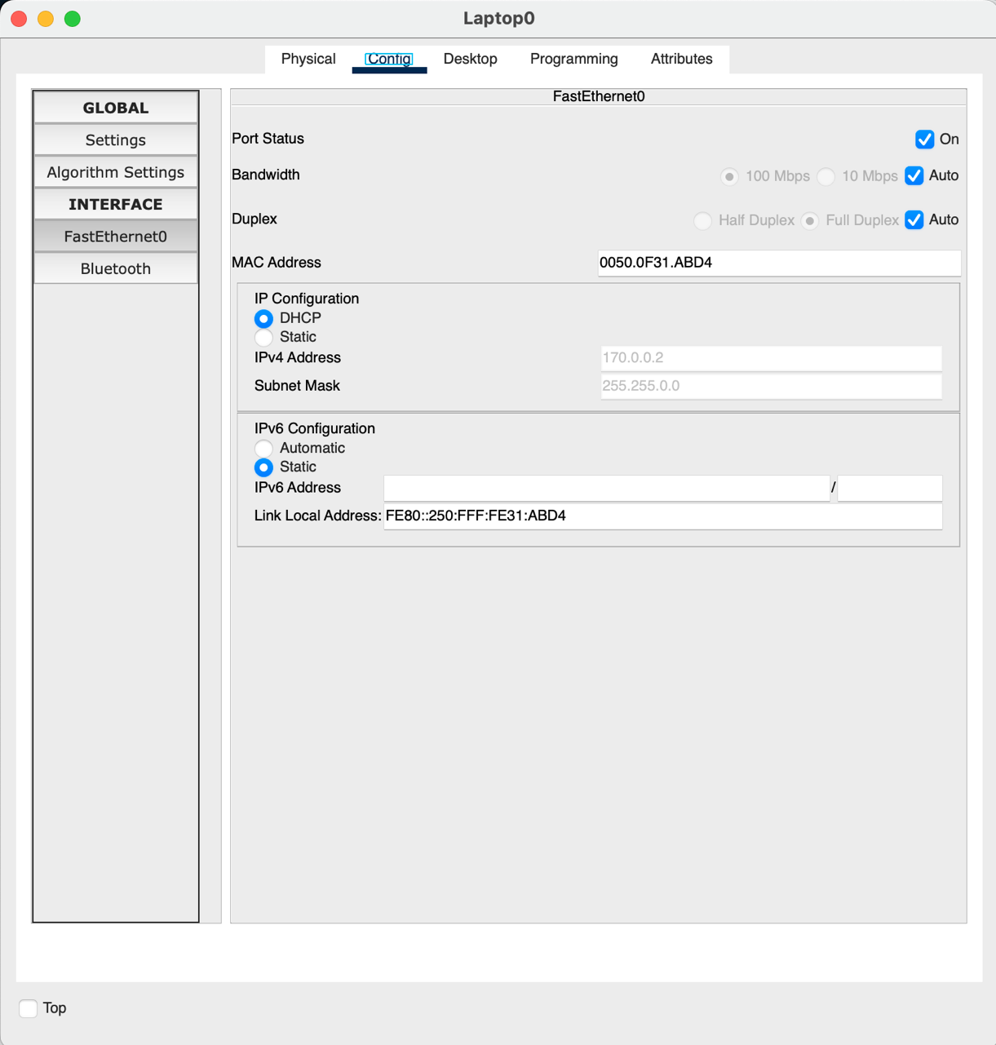

3. Show that Laptop 1 did acquire a valid IP address from the DHCP server (replace my screen capture with yours)

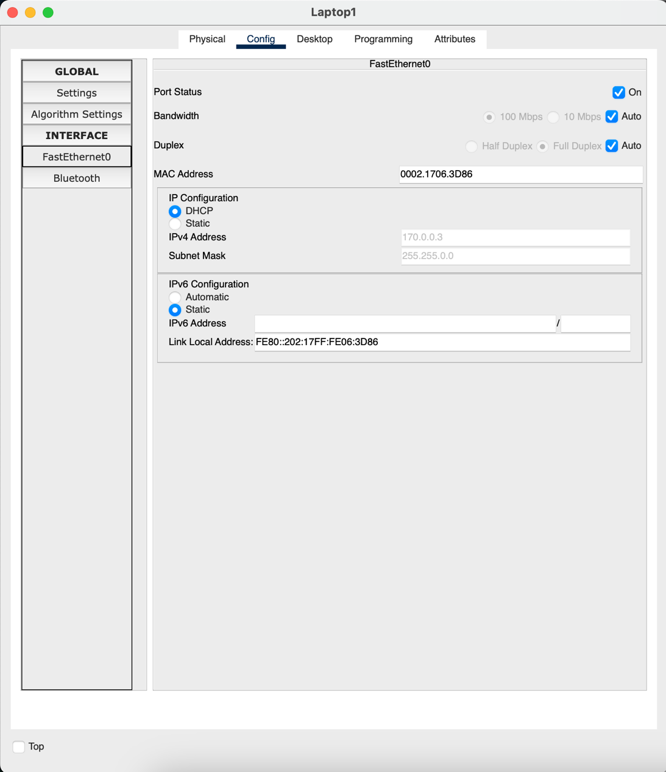

4. Show that you can ping from Laptop 0 to Laptop 1:

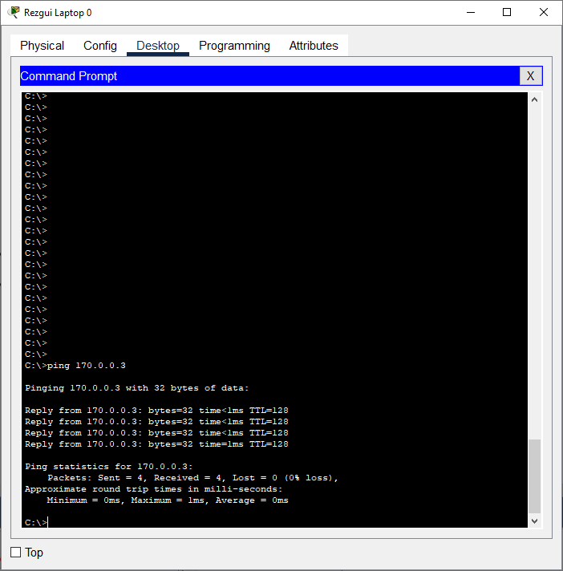

**Task 2 – DHCP/DNS/HTTP (50 points)**

5. Add a router and a Web server with URL: www.your_name.edu as shown:

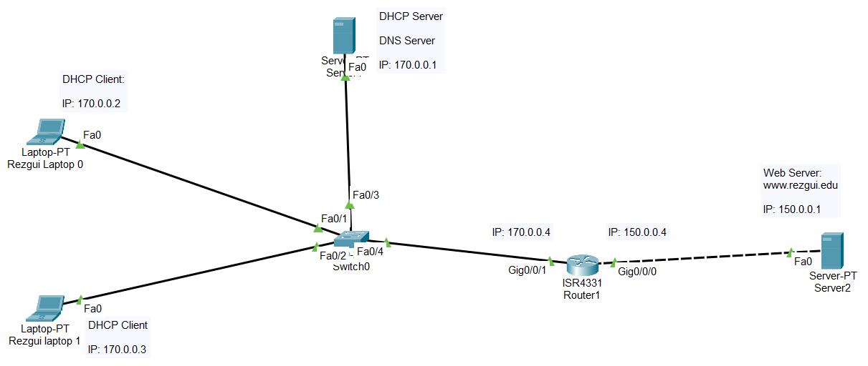

6. Configure the DHCP server to also provide the IP of the gateway (170.0.0.4) and the IP of a DNS server (running on the same machine as the DHCP server) as follows:

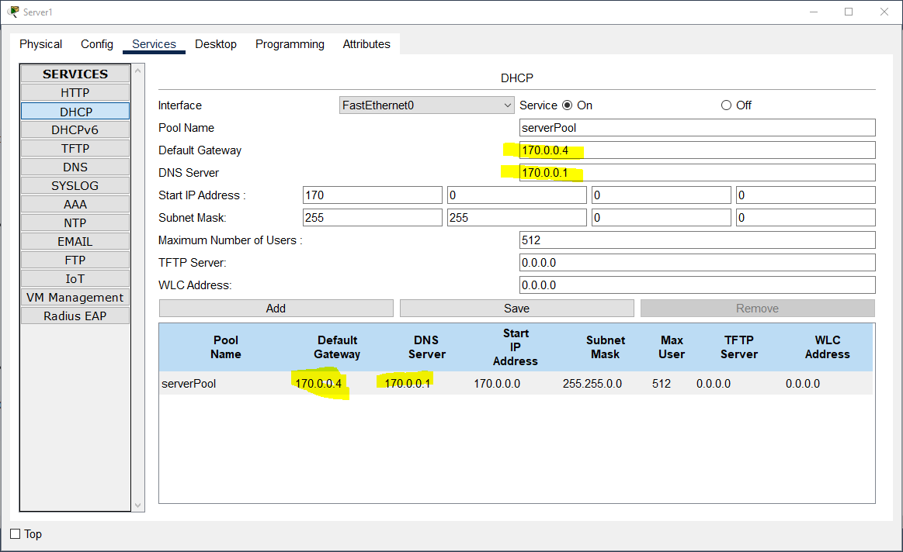

7. Make sure that each laptop now has acquired the proper IPs for the gatway and the DNS server as shown here:

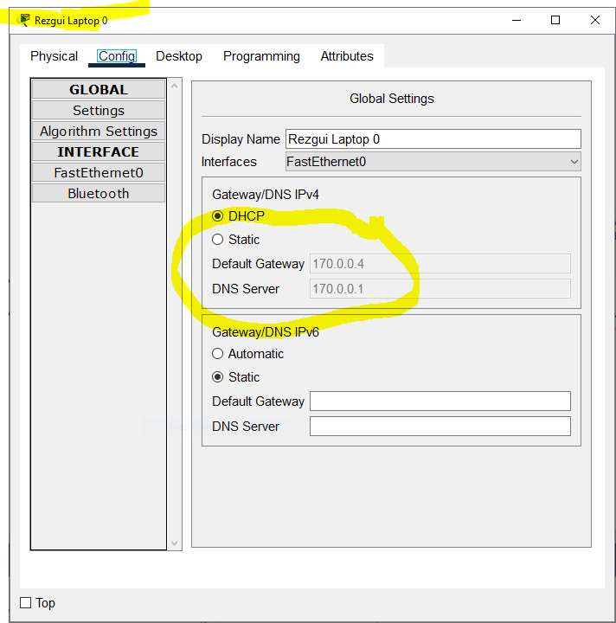

8. Configure the Web server to use 150.0.0.4 as its gateway (as done in a previous lab)

9. Configure the Web server to show YOUR NAME in the main page (as we did in previous labs)

10. Configure the DNS server to map [www.your_name.edu](http://www.your_name.edu) to 150.0.0.1 (as we did in previous labs)

11. Insert a screen shot that shows that you can access [www.your_name.edu](http://www.your_name.edu) from each of the two laptops as shown below (my URL is: www.rezgui.edu)

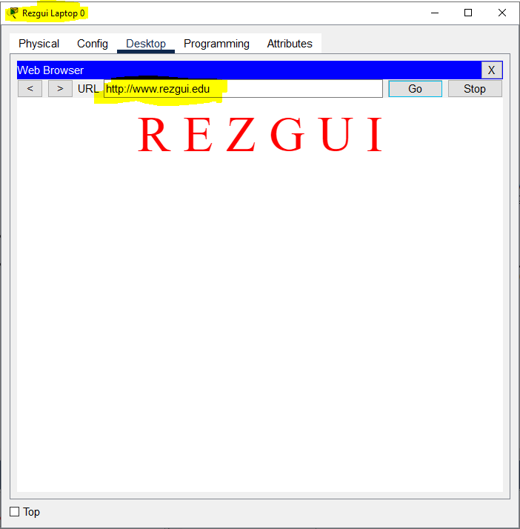

**Submission**

Save your Packet Tracer file (.pkt) and upload to Canvas:

- This Word file

- The .pkt file